REGRESSION

/MISSING LISTWISE

/STATISTICS COEFF OUTS R ANOVA CHANGE

/CRITERIA=PIN(.05) POUT(.10)

/NOORIGIN

/DEPENDENT Sociallanguagescores

/METHOD=ENTER Deprivedenviroments_v2Chaoticenviroment_v2Poolivingcondit ions_v2

LowSESconditions_v2Timespentinschools /SCATTERPLOT=(*ZRESID ,*ZPRED)

/RESIDUALS DURBIN HISTOGRAM(ZRESID) NORMPROB(ZRESID).

Regression

Variables Entered/Removed ª

 | Variables | Variables
Model | Entered | Removed | Method
1 | Time spent | . | Enter
 | in schools,
 | LowSEScondit
 | ions_v2,
 | Deprivedenvi
 | roments_v2,
 | Chaoticenviro
 | ment_v2,
 | Poorlivingcon
 | ditions_v2^{b}

- Dependent Variable: Sociallanguagescores

- All requested variables entered.

Model Summary ^{b}

 |  |  |  |  |  |  |  | Change Statistics
 |  |  |  |  | Adjusted R |  | Std. Error of | R Square
Model | R |  | R Square |  | Square |  | the Estimate | Change | F Change
1 | . 359 ª |  | .129 |  | .069 |  | 1.333 | .129 | 2.137
 |  |  |  |  | Model Summary ^{b}
 |  | Change Statistics
 |  |  |  |  |  |  | Durbin-
Model | df1 |  | df2 |  | Sig. F Change |  | Watson
1 | 5 |  | 7 2 |  | .071 |  | 2.256

- Predictors: (Constant), Time spent in schools, LowSESconditions_v2, Deprivedenviroments_v2, Chaoticenviroment_v2, Poorlivingconditions_v2

- Dependent Variable: Sociallanguagescores

Page 1

ANOVAª

 |  | Sum of
Model |  | Squares |  | df | Mean Square | F | Sig.
1 | Regression | 18 | .982 | 5 | 3.796 | 2.137 | . 071 ^{b}
 | Residual | 127 | .890 | 7 2 | 1.776
 | Total | 146 | .872 | 7 7

- Dependent Variable: Sociallanguagescores

- Predictors: (Constant), Time spent in schools, LowSESconditions_v2, Deprivedenviroments_v2, Chaoticenviroment_v2, Poorlivingconditions_v2

Coefficientsª

 |  |  |  |  | Standardized
 |  | Unstandardized Coefficients |  |  | Coefficients
Model |  | B |  | Std. Error | Beta | t
1 | (Constant) | 5.218 |  | .719 |  | 7.262
 | Deprivedenviroments_v2 | .151 |  | .539 | .053 | .279
 | Chaoticenviroment_v2 | -.562 |  | .577 | -.182 | - . 9 | 7 3
 | Poorlivingconditions_v2 | -1.795 |  | .691 | -.652 | -2.5 | 9 7
 | LowSESconditions_v2 | -1.126 |  | .682 | -.410 | -1.6 | 5 0
 | Time spent in schools | -.001 |  | .004 | -.032 | - . 2 | 8 2

Coefficientsª

Model |  | Sig.
1 | (Constant) | .000
 | Deprivedenviroments_v2 | .781

Chaoticenviroment_v2 . 334

Poorlivingconditions_v2 . 011

LowSESconditions_v2 . 103

Time spent in schools . 779

a. Dependent Variable: Sociallanguagescores

Residuals Statisticsª

 | Minimum | Maximum | Mean | Std. Deviation | N
Predicted Value | 2.73 | 5.18 | 3.74 | .497 | 7 8
Residual | -2.528 | 2.589 | .000 | 1.289 | 7 8
Std. Predicted Value | -2.041 | 2.896 | .000 | 1.000 | 7 8
Std. Residual | -1.897 | 1.942 | .000 | .967 | 7 8

a. Dependent Variable: Sociallanguagescores

Page 2

Charts

Frequency

2 0

1 5

1 0

5

0

Histogram

Dependent Variable: Sociallanguagescores
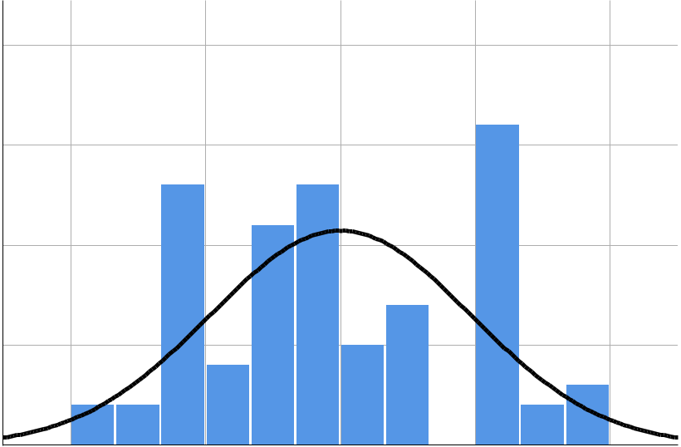

Mean = - 2 . 3 8 E - 1 6

Std. Dev. = 0 . 9 6 7
N =78

-2 -1 0 1 2

Regression Standardized Residual

Normal P-P Plot of Regression Standardized Residual

Dependent Variable: Sociallanguagescores

 | 1 . 0
 | 0 . 8
Prob | 0 . 6
Cum
Expected | 0 . 4
 | 0 . 2
 | 0 . 0
 | 0 . 0 | 0 . 2 | 0 . 4 | 0 . 6 | 0 . 8 | 1 . 0
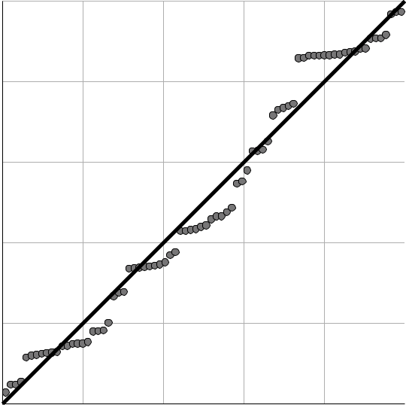

Observed Cum Prob

Page 3

Scatterplot

Dependent Variable: Sociallanguagescores
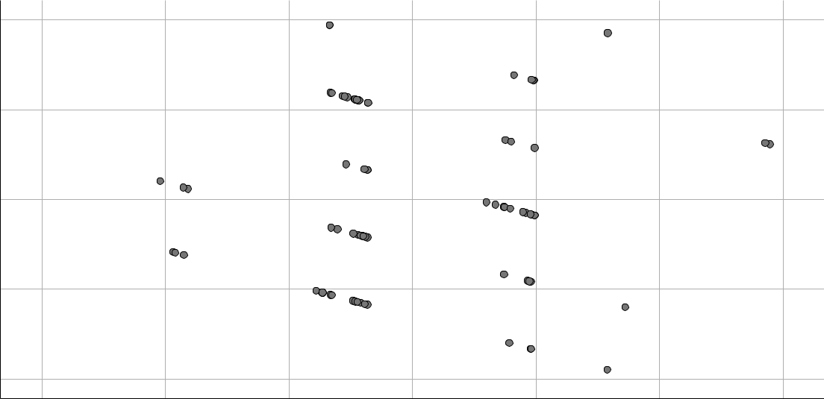

Regression Standardized Residual

2

1

0

- 1

- 2

-3 -2 -1 0 1 2 3

Regression Standardized Predicted Value

REGRESSION

/MISSING LISTWISE

/STATISTICS COEFF OUTS R ANOVA CHANGE

/CRITERIA=PIN(.05) POUT(.10)

/NOORIGIN

/DEPENDENT Sociallanguagescores

/METHOD=ENTER Deprivedenviroments_v2Chaoticenviroment_v2Poolivingcondit ions_v2

LowSESconditions_v2Timespentinschools /SCATTERPLOT=(*ZRESID ,*ZPRED)

/RESIDUALS DURBIN HISTOGRAM(ZRESID) NORMPROB(ZRESID).

Regression

Variables Entered/Removed ª

 | Variables | Variables
Model | Entered | Removed | Method
1 | Time spent | . | Enter
 | in schools,
 | LowSEScondit
 | ions_v2,
 | Deprivedenvi
 | roments_v2,
 | Chaoticenviro
 | ment_v2,
 | Poorlivingcon
 | ditions_v2^{b}

- Dependent Variable: Sociallanguagescores

- All requested variables entered.

Page 4

Model Summary ^{b}

 |  |  |  |  |  |  |  | Change Statistics
 |  |  |  |  | Adjusted R |  | Std. Error of | R Square
Model | R |  | R Square |  | Square |  | the Estimate | Change | F Change
1 | . 359 ª |  | .129 |  | .069 |  | 1.333 | .129 | 2.137
 |  |  |  |  | Model Summary ^{b}
 |  | Change Statistics
 |  |  |  |  |  |  | Durbin-
Model | df1 |  | df2 |  | Sig. F Change |  | Watson
1 | 5 |  | 7 2 |  | .071 |  | 2.256

- Predictors: (Constant), Time spent in schools, LowSESconditions_v2, Deprivedenviroments_v2, Chaoticenviroment_v2, Poorlivingconditions_v2

- Dependent Variable: Sociallanguagescores

ANOVAª

 |  | Sum of
Model |  | Squares |  | df | Mean Square | F | Sig.
1 | Regression | 18 | .982 | 5 | 3.796 | 2.137 | . 071 ^{b}
 | Residual | 127 | .890 | 7 2 | 1.776
 | Total | 146 | .872 | 7 7

- Dependent Variable: Sociallanguagescores

- Predictors: (Constant), Time spent in schools, LowSESconditions_v2, Deprivedenviroments_v2, Chaoticenviroment_v2, Poorlivingconditions_v2

Coefficientsª

 |  |  |  |  | Standardized
 |  | Unstandardized Coefficients |  |  | Coefficients
Model |  | B |  | Std. Error | Beta | t
1 | (Constant) | 5.218 |  | .719 |  | 7.262
 | Deprivedenviroments_v2 | .151 |  | .539 | .053 | .279
 | Chaoticenviroment_v2 | -.562 |  | .577 | -.182 | - . 9 | 7 3
 | Poorlivingconditions_v2 | -1.795 |  | .691 | -.652 | -2.5 | 9 7
 | LowSESconditions_v2 | -1.126 |  | .682 | -.410 | -1.6 | 5 0
 | Time spent in schools | -.001 |  | .004 | -.032 | - . 2 | 8 2

Page 5

Coefficientsª

Model |  | Sig.
1 | (Constant) | .000
 | Deprivedenviroments_v2 | .781

Chaoticenviroment_v2 . 334

Poorlivingconditions_v2 . 011

LowSESconditions_v2 . 103

Time spent in schools . 779

a. Dependent Variable: Sociallanguagescores

Residuals Statisticsª

 | Minimum | Maximum | Mean | Std. Deviation | N
Predicted Value | 2.73 | 5.18 | 3.74 | .497 | 7 8
Residual | -2.528 | 2.589 | .000 | 1.289 | 7 8
Std. Predicted Value | -2.041 | 2.896 | .000 | 1.000 | 7 8
Std. Residual | -1.897 | 1.942 | .000 | .967 | 7 8

a. Dependent Variable: Sociallanguagescores

Charts

Frequency

2 0

1 5

1 0

5

0

Histogram

Dependent Variable: Sociallanguagescores
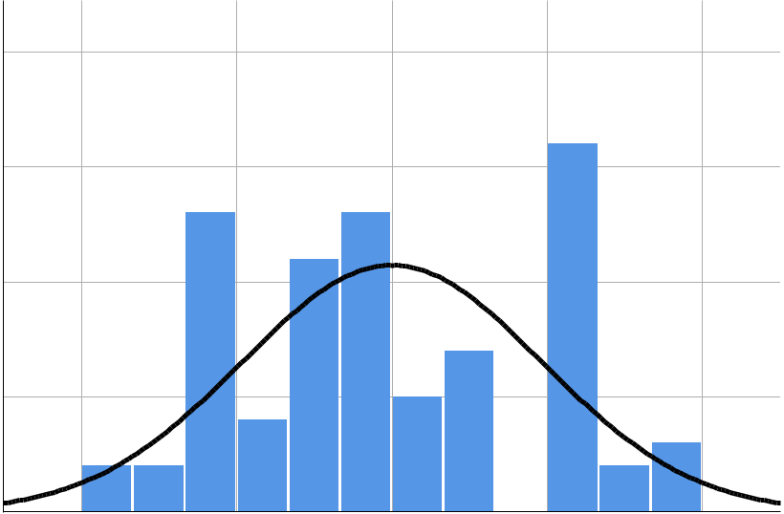

Mean = - 2 . 3 8 E - 1 6

Std. Dev. = 0 . 9 6 7
N =78

-2 -1 0 1 2

Regression Standardized Residual

Page 6

Normal P-P Plot of Regression Standardized Residual

Dependent Variable: Sociallanguagescores

Expected Cum Prob

1 . 0

0 . 8

0 . 6

0 . 4

0 . 2

0 . 0
0.0 0.2 0.4 0.6 0.8 1.0

Observed Cum Prob

Scatterplot

Dependent Variable: Sociallanguagescores
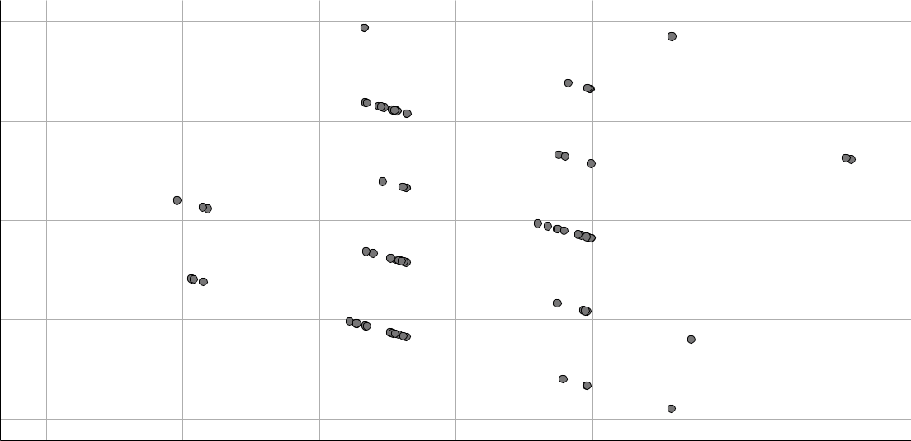

Regression Standardized Residual

2

1

0

- 1

- 2

-3 -2 -1 0 1 2 3

Regression Standardized Predicted Value

REGRESSION

/MISSING LISTWISE

/STATISTICS COEFF OUTS R ANOVA CHANGE

/CRITERIA=PIN(.05) POUT(.10)

/NOORIGIN

/DEPENDENT Sociallanguagescores

/METHOD=ENTER Deprivedenviroments_v2Chaoticenviroment_v2Poolivingcondit ions_v2

Page 7

LowSESconditions_v2Timespentinschools /SCATTERPLOT=(*ZRESID ,*ZPRED)

/RESIDUALS DURBIN HISTOGRAM(ZRESID) NORMPROB(ZRESID)

/SAVE ZPRED COOK LEVER ZRESID.

Regression

Variables Entered/Removed ª

 | Variables | Variables
Model | Entered | Removed | Method
1 | Time spent | . | Enter
 | in schools,
 | LowSEScondit
 | ions_v2,
 | Deprivedenvi
 | roments_v2,
 | Chaoticenviro
 | ment_v2,
 | Poorlivingcon
 | ditions_v2^{b}

- Dependent Variable: Sociallanguagescores

- All requested variables entered.

Model Summary ^{b}

 |  |  |  |  |  |  |  | Change Statistics
 |  |  |  |  | Adjusted R |  | Std. Error of | R Square
Model | R |  | R Square |  | Square |  | the Estimate | Change | F Change
1 | . 359 ª |  | .129 |  | .069 |  | 1.333 | .129 | 2.137
 |  |  |  |  | Model Summary ^{b}
 |  | Change Statistics
 |  |  |  |  |  |  | Durbin-
Model | df1 |  | df2 |  | Sig. F Change |  | Watson
1 | 5 |  | 7 2 |  | .071 |  | 2.256

- Predictors: (Constant), Time spent in schools, LowSESconditions_v2, Deprivedenviroments_v2, Chaoticenviroment_v2, Poorlivingconditions_v2

- Dependent Variable: Sociallanguagescores

ANOVAª

 |  | Sum of
Model |  | Squares |  | df | Mean Square | F | Sig.
1 | Regression | 18 | .982 | 5 | 3.796 | 2.137 | . 071 ^{b}
 | Residual | 127 | .890 | 7 2 | 1.776
 | Total | 146 | .872 | 7 7

- Dependent Variable: Sociallanguagescores

- Predictors: (Constant), Time spent in schools, LowSESconditions_v2, Deprivedenviroments_v2, Chaoticenviroment_v2, Poorlivingconditions_v2

Page 8

Coefficientsª

 |  |  |  |  | Standardized
 |  | Unstandardized Coefficients |  |  | Coefficients
Model |  | B |  | Std. Error | Beta | t
1 | (Constant) | 5.218 |  | .719 |  | 7.262
 | Deprivedenviroments_v2 | .151 |  | .539 | .053 | .279
 | Chaoticenviroment_v2 | -.562 |  | .577 | -.182 | - . 9 | 7 3
 | Poorlivingconditions_v2 | -1.795 |  | .691 | -.652 | -2.5 | 9 7
 | LowSESconditions_v2 | -1.126 |  | .682 | -.410 | -1.6 | 5 0
 | Time spent in schools | -.001 |  | .004 | -.032 | - . 2 | 8 2

Coefficientsª

Model |  | Sig.
1 | (Constant) | .000
 | Deprivedenviroments_v2 | .781

Chaoticenviroment_v2 . 334

Poorlivingconditions_v2 . 011

LowSESconditions_v2 . 103

Time spent in schools . 779

a. Dependent Variable: Sociallanguagescores

Residuals Statisticsª

 | Minimum | Maximum |  | Mean | Std. Deviation | N
Predicted Value | 2.73 |  | 5.18 | 3.74 | .497 | 7 8
Std. Predicted Value | -2.041 | 2 | .896 | .000 | 1.000 | 7 8
Standard Error of | .242 |  | .691 | .351 | .115 | 7 8
Predicted Value
Adjusted Predicted Value | 2.70 |  | 5.31 | 3.75 | .514 | 7 8
Residual | -2.528 | 2 | .589 | .000 | 1.289 | 7 8
Std. Residual | -1.897 | 1 | .942 | .000 | .967 | 7 8
Stud. Residual | -2.171 | 2 | .121 | -.002 | 1.016 | 7 8
Deleted Residual | -3.312 | 3 | .235 | -.005 | 1.429 | 7 8
Stud. Deleted Residual | -2.230 | 2 | .176 | -.001 | 1.025 | 7 8
Mahal. Distance | 1.546 | 19 | .695 | 4.936 | 4.408 | 7 8
Cook's Distance | .000 |  | .244 | .019 | .041 | 7 8
Centered Leverage Value | .020 |  | .256 | .064 | .057 | 7 8

a. Dependent Variable: Sociallanguagescores

Page 9

Charts

Frequency

2 0

1 5

1 0

5

0

Histogram

Dependent Variable: Sociallanguagescores

Mean = - 2 . 3 8 E - 1 6

Std. Dev. = 0 . 9 6 7
N =78

-2 -1 0 1 2

Regression Standardized Residual

Normal P-P Plot of Regression Standardized Residual

Dependent Variable: Sociallanguagescores

 | 1 . 0
 | 0 . 8
Prob | 0 . 6
Cum
Expected | 0 . 4
 | 0 . 2
 | 0 . 0
 | 0 . 0 | 0 . 2 | 0 . 4 | 0 . 6 | 0 . 8 | 1 . 0

Observed Cum Prob

Page 10

Scatterplot

Dependent Variable: Sociallanguagescores

Regression Standardized Residual

2

1

0

- 1

- 2

-3 -2 -1 0 1 2 3

Regression Standardized Predicted Value

GRAPH

/SCATTERPLOT(BIVAR)=ZPR_10 WITH ZRE_10

/MISSING=LISTWISE.

Graph
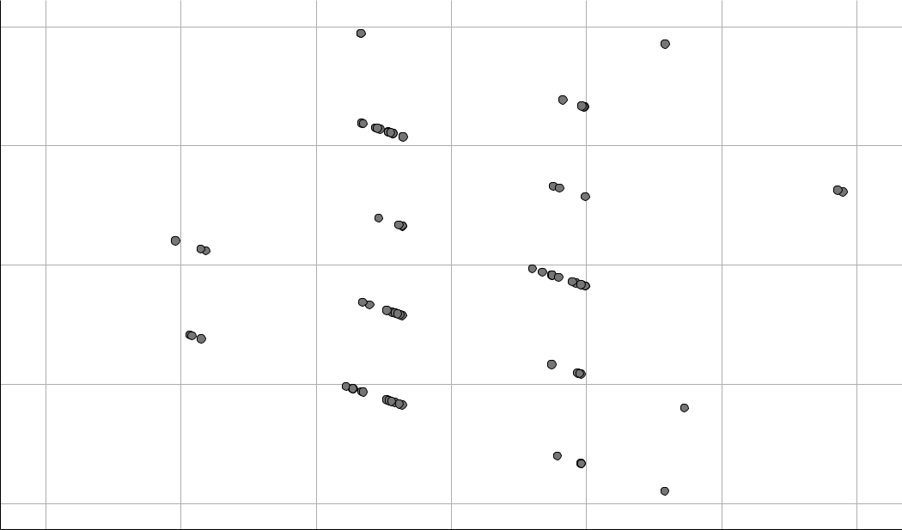

Standardized Residual

2.00000

1.00000

.00000

-1.00000

-2.00000

-3.00000 -2.00000 -1.00000 .00000 1.00000 2.00000 3.00000

Standardized Predicted Value

REGRESSION

Page 11

/DESCRIPTIVES MEAN STDDEV CORR SIG N

/MISSING LISTWISE

/STATISTICS COEFF OUTS CI(95) BCOV R ANOVA COLLIN TOL /CRITERIA=PIN(.05) POUT(.10) /NOORIGIN

/DEPENDENT Sociallanguagescores

/METHOD=ENTER Deprivedenviroments_v2Chaoticenviroment_v2Poolivingcondit ions_v2

LowSESconditions_v2Timespentinschools /SCATTERPLOT=(*ZRESID ,*ZPRED)

/RESIDUALS HISTOGRAM(ZRESID) NORMPROB(ZRESID)

/SAVE ZPRED COOK LEVER ZRESID.

Regression

Descriptive Statistics

 | Mean |  | Std. Deviation |  | N
Sociallanguagescores | 3 | . 74 | 1 | .381 | 7 8
Deprivedenviroments_v2 |  | . 63 |  | .486 | 7 8
Chaoticenviroment_v2 |  | . 27 |  | .446 | 7 8
Poorlivingconditions_v2 |  | . 46 |  | .502 | 7 8
LowSESconditions_v2 |  | . 47 |  | .503 | 7 8
Time spent in schools | 46 | .68 | 37 | .467 | 7 8

Page 12

Correlations

 |  | Sociallanguage | Deprivedenvir | Chaoticenviro
 |  | scores | oments_v2 | ment_v2
Pearson Correlation | Sociallanguagescores | 1.000 | .088 | -.139
 | Deprivedenviroments_v2 | .088 | 1.000 | -.789
 | Chaoticenviroment_v2 | -.139 | -.789 | 1.000
 | Poorlivingconditions_v2 | -.239 | .180 | -.214
 | LowSESconditions_v2 | .140 | -.013 | .118
 | Time spent in schools | -.018 | -.126 | .222
Sig. (1-tailed) | Sociallanguagescores | . | .221 | .112
 | Deprivedenviroments_v2 | .221 | . | .000
 | Chaoticenviroment_v2 | .112 | .000 | .
 | Poorlivingconditions_v2 | .017 | .057 | .030
 | LowSESconditions_v2 | .111 | .455 | .152
 | Time spent in schools | .439 | .137 | .025
N | Sociallanguagescores | 7 8 | 7 8 | 7 8
 | Deprivedenviroments_v2 | 7 8 | 7 8 | 7 8
 | Chaoticenviroment_v2 | 7 8 | 7 8 | 7 8
 | Poorlivingconditions_v2 | 7 8 | 7 8 | 7 8
 | LowSESconditions_v2 | 7 8 | 7 8 | 7 8
 | Time spent in schools | 7 8 | 7 8 | 7 8

Page 13

Correlations

 |  | Poorlivingcondi | LowSESconditio | Time spent in
 |  | tions_v2 | ns_v2 | schools
Pearson Correlation | Sociallanguagescores | -.239 | .140 | -.018
 | Deprivedenviroments_v2 | .180 | -.013 | -.126
 | Chaoticenviroment_v2 | -.214 | .118 | .222
 | Poorlivingconditions_v2 | 1.000 | -.879 | -.128
 | LowSESconditions_v2 | -.879 | 1.000 | .054
 | Time spent in schools | -.128 | .054 | 1.000
Sig. (1-tailed) | Sociallanguagescores | .017 | .111 | .439
 | Deprivedenviroments_v2 | .057 | .455 | .137
 | Chaoticenviroment_v2 | .030 | .152 | .025
 | Poorlivingconditions_v2 | . | .000 | .132
 | LowSESconditions_v2 | .000 | . | .320
 | Time spent in schools | .132 | .320 | .
N | Sociallanguagescores | 7 8 | 7 8 | 7 8
 | Deprivedenviroments_v2 | 7 8 | 7 8 | 7 8
 | Chaoticenviroment_v2 | 7 8 | 7 8 | 7 8
 | Poorlivingconditions_v2 | 7 8 | 7 8 | 7 8
 | LowSESconditions_v2 | 7 8 | 7 8 | 7 8
 | Time spent in schools | 7 8 | 7 8 | 7 8

Variables Entered/Removed ª

 | Variables | Variables
Model | Entered | Removed | Method
1 | Time spent | . | Enter
 | in schools,
 | LowSEScondit
 | ions_v2,
 | Deprivedenvi
 | roments_v2,
 | Chaoticenviro
 | ment_v2,
 | Poorlivingcon
 | ditions_v2^{b}

- Dependent Variable: Sociallanguagescores

- All requested variables entered.

Page 14

Model Summary ^{b}

 |  |  | Adjusted R | Std. Error of
Model | R | R Square | Square | the Estimate
1 | . 359 ª | .129 | .069 | 1.333

- Predictors: (Constant), Time spent in schools, LowSESconditions_v2, Deprivedenviroments_v2, Chaoticenviroment_v2, Poorlivingconditions_v2

- Dependent Variable: Sociallanguagescores

ANOVAª

 |  | Sum of
Model |  | Squares |  | df | Mean Square | F | Sig.
1 | Regression | 18 | .982 | 5 | 3.796 | 2.137 | . 071 ^{b}
 | Residual | 127 | .890 | 7 2 | 1.776
 | Total | 146 | .872 | 7 7

- Dependent Variable: Sociallanguagescores

- Predictors: (Constant), Time spent in schools, LowSESconditions_v2, Deprivedenviroments_v2, Chaoticenviroment_v2, Poorlivingconditions_v2

Coefficientsª

 |  |  |  |  | Standardized
 |  | Unstandardized Coefficients |  |  | Coefficients
Model |  | B |  | Std. Error | Beta | t
1 | (Constant) | 5.218 |  | .719 |  | 7.262
 | Deprivedenviroments_v2 | .151 |  | .539 | .053 | .279
 | Chaoticenviroment_v2 | -.562 |  | .577 | -.182 | - . 9 | 7 3
 | Poorlivingconditions_v2 | -1.795 |  | .691 | -.652 | -2.5 | 9 7
 | LowSESconditions_v2 | -1.126 |  | .682 | -.410 | -1.6 | 5 0
 | Time spent in schools | -.001 |  | .004 | -.032 | - . 2 | 8 2

Coefficientsª

 |  |  |  |  |  | Collinearity
 |  |  | 95.0% Confidence Interval for B |  |  | Statistics
Model |  | Sig. | Lower Bound |  | Upper Bound | Tolerance
1 | (Constant) | .000 | 3.786 |  | 6.651
 | Deprivedenviroments_v2 | .781 | -.924 |  | 1.225 | .336
 | Chaoticenviroment_v2 | .334 | -1.713 |  | .589 | .347
 | Poorlivingconditions_v2 | .011 | -3.173 |  | -.417 | .192
 | LowSESconditions_v2 | .103 | -2.485 |  | .234 | .196
 | Time spent in schools | .779 | -.010 |  | .007 | .921

Page 15

Coefficientsª

Collinearity
Statistics

Model ^{VIF}
- (Constant)

Deprivedenviroments_v22 .980

Chaoticenviroment_v2 2 .879

Poorlivingconditions_v2 5 .212

LowSESconditions_v2 5 .094

Time spent in schools 1 .086

a. Dependent Variable: Sociallanguagescores

Coefficient Correlations ª

 |  |  | Time spent in |  | LowSESconditio | Deprivedenvir
Model |  |  | schools |  | ns_v2 | oments_v2
1 | Correlations | Time spent in schools | 1.000 |  | .131 | -.121
 |  | LowSESconditions_v2 | .131 |  | 1.000 | -.323
 |  | Deprivedenviroments_v2 | -.121 |  | -.323 | 1.000
 |  | Chaoticenviroment_v2 | -.209 |  | -.177 | .784
 |  | Poorlivingconditions_v2 | .156 |  | .893 | -.299
 | Covariances | Time spent in schools | 1.784E-5 |  | .000 | .000
 |  | LowSESconditions_v2 | .000 |  | .465 | -.119
 |  | Deprivedenviroments_v2 | .000 |  | -.119 | .291
 |  | Chaoticenviroment_v2 | -.001 |  | -.070 | .244
 |  | Poorlivingconditions_v2 | .000 |  | .421 | -.112
 |  | Coefficient Correlations ª
 |  |  | Chaoticenviro |  | Poorlivingcondi
Model |  |  | ment_v2 |  | tions_v2
1 | Correlations | Time spent in schools | -.209 |  | .156
 |  | LowSESconditions_v2 | -.177 |  | .893
 |  | Deprivedenviroments_v2 | .784 |  | -.299
 |  | Chaoticenviroment_v2 | 1.000 |  | -.114
 |  | Poorlivingconditions_v2 | -.114 |  | 1.000
 | Covariances | Time spent in schools | -.001 |  | .000
 |  | LowSESconditions_v2 | -.070 |  | .421
 |  | Deprivedenviroments_v2 | .244 |  | -.112
 |  | Chaoticenviroment_v2 | .333 |  | -.045
 |  | Poorlivingconditions_v2 | -.045 |  | .478

Page 16

a. Dependent Variable: Sociallanguagescores

Collinearity Diagnostics ª

 |  |  |  |  |  | Variance Proportions
 |  |  | Condition |  |  | Deprivedenvir |  | Chaoticenviro
Model | Dimension | Eigenvalue | Index |  | (Constant) | oments_v2 |  | ment_v2
1 | 1 | 3.575 | 1 | .000 | .00 | .01 |  | .01
 | 2 | 1.176 | 1 | .744 | .00 | .02 |  | .08
 | 3 | .851 | 2 | .050 | .00 | .02 |  | .09
 | 4 | .305 | 3 | .425 | .01 | .00 |  | .07
 | 5 | .065 | 7 | .409 | .07 | .94 |  | .72
 | 6 | .028 | 11 | .322 | .92 | .01 |  | .04

Collinearity Diagnostics ª

 |  | Variance Proportions
 |  | Poorlivingcondi | LowSESconditio | Time spent in
Model | Dimension | tions_v2 | ns_v2 | schools
1 | 1 | .00 | .00 | .02
 | 2 | .03 | .02 | .00
 | 3 | .03 | .04 | .00
 | 4 | .01 | .02 | .90
 | 5 | .16 | .19 | .01
 | 6 | .77 | .73 | .07

a. Dependent Variable: Sociallanguagescores

Page 17

Residuals Statisticsª

 | Minimum | Maximum |  | Mean | Std. Deviation | N
Predicted Value | 2.73 |  | 5.18 | 3.74 | .497 | 7 8
Std. Predicted Value | -2.041 | 2 | .896 | .000 | 1.000 | 7 8
Standard Error of | .242 |  | .691 | .351 | .115 | 7 8
Predicted Value
Adjusted Predicted Value | 2.70 |  | 5.31 | 3.75 | .514 | 7 8
Residual | -2.528 | 2 | .589 | .000 | 1.289 | 7 8
Std. Residual | -1.897 | 1 | .942 | .000 | .967 | 7 8
Stud. Residual | -2.171 | 2 | .121 | -.002 | 1.016 | 7 8
Deleted Residual | -3.312 | 3 | .235 | -.005 | 1.429 | 7 8
Stud. Deleted Residual | -2.230 | 2 | .176 | -.001 | 1.025 | 7 8
Mahal. Distance | 1.546 | 19 | .695 | 4.936 | 4.408 | 7 8
Cook's Distance | .000 |  | .244 | .019 | .041 | 7 8
Centered Leverage Value | .020 |  | .256 | .064 | .057 | 7 8

a. Dependent Variable: Sociallanguagescores

Charts

Frequency

2 0

1 5

1 0

5

0

Histogram

Dependent Variable: Sociallanguagescores

Mean = - 2 . 3 8 E - 1 6

Std. Dev. = 0 . 9 6 7
N =78

-2 -1 0 1 2

Regression Standardized Residual

Page 18

Regression Standardized Residual

Normal P-P Plot of Regression Standardized Residual

Dependent Variable: Sociallanguagescores

 | 1 . 0
 | 0 . 8
Prob | 0 . 6
Cum
Expected | 0 . 4
 | 0 . 2
 | 0 . 0
 | 0 . 0 | 0 . 2 | 0 . 4 | 0 . 6 | 0 . 8 | 1 . 0

Observed Cum Prob

Scatterplot

Dependent Variable: Sociallanguagescores

2

1

0

- 1

- 2

-3 -2 -1 0 1 2 3

Regression Standardized Predicted Value

Page 19

