REGRESSION

/MISSING LISTWISE

/STATISTICS COEFF OUTS R ANOVA CHANGE

/CRITERIA=PIN(.05) POUT(.10)

/NOORIGIN

/DEPENDENT Semanticlanguagescores

/METHOD=ENTER Deprivedenviroments_v2Chaoticenviroment_v2Poolivingcondit ions_v2

LowSESconditions_v2

/SCATTERPLOT=(*ZRESID ,*ZPRED)

/RESIDUALS DURBIN HISTOGRAM(ZRESID) NORMPROB(ZRESID).

Regression

Variables Entered/Removed ª

 | Variables | Variables
Model | Entered | Removed | Method
1 | LowSEScondit | . | Enter
 | ions_v2,
 | Deprivedenvi
 | roments_v2,
 | Chaoticenviro
 | ment_v2,
 | Poorlivingcon
 | ditions_v2^{b}

- Dependent Variable: Semanticlanguagescores

- All requested variables entered.

Model Summary ^{b}

 |  |  |  |  |  |  |  | Change Statistics
 |  |  |  |  | Adjusted R |  | Std. Error of | R Square
Model | R |  | R Square |  | Square |  | the Estimate | Change | F Change
1 | . 376 ª |  | .141 |  | .094 |  | 1.572 | .141 | 2.999
 |  |  |  |  | Model Summary ^{b}
 |  | Change Statistics
 |  |  |  |  |  |  | Durbin-
Model | df1 |  | df2 |  | Sig. F Change |  | Watson
1 | 4 |  | 7 3 |  | .024 |  | 1.971

- Predictors: (Constant), LowSESconditions_v2, Deprivedenviroments_v2, Chaoticenviroment_v2, Poorlivingconditions_v2

- Dependent Variable: Semanticlanguagescores

Page 1

ANOVAª

 |  | Sum of
Model |  | Squares |  | df | Mean Square | F | Sig.
1 | Regression | 29 | .664 | 4 | 7.416 | 2.999 | . 024 ^{b}
 | Residual | 180 | .489 | 7 3 | 2.472
 | Total | 210 | .154 | 7 7

- Dependent Variable: Semanticlanguagescores

- Predictors: (Constant), LowSESconditions_v2, Deprivedenviroments_v2, Chaoticenviroment_v2, Poorlivingconditions_v2

Coefficientsª

 |  |  |  |  | Standardized
 |  | Unstandardized Coefficients |  |  | Coefficients
Model |  | B |  | Std. Error | Beta | t
1 | (Constant) | 6.794 |  | .809 |  | 8.400
 | Deprivedenviroments_v2 | 1.224 |  | .631 | .360 | 1.940
 | Chaoticenviroment_v2 | .343 |  | .666 | .093 | .515
 | Poorlivingconditions_v2 | -.458 |  | .805 | -.139 | - . 5 | 6 8
 | LowSESconditions_v2 | -1.261 |  | .798 | -.384 | -1.5 | 8 1

Coefficientsª

Model |  | Sig.
1 | (Constant) | .000
 | Deprivedenviroments_v2 | .056

Chaoticenviroment_v2 . 608

Poorlivingconditions_v2 . 571

LowSESconditions_v2 . 118

a. Dependent Variable: Semanticlanguagescores

Residuals Statisticsª

 | Minimum | Maximum | Mean | Std. Deviation | N
Predicted Value | 5.53 | 7.56 | 6.85 | .621 | 7 8
Residual | -2.757 | 3.439 | .000 | 1.531 | 7 8
Std. Predicted Value | -2.116 | 1.151 | .000 | 1.000 | 7 8
Std. Residual | -1.754 | 2.187 | .000 | .974 | 7 8

a. Dependent Variable: Semanticlanguagescores

Page 2

Charts

Histogram

Dependent Variable: Semanticlanguagescores
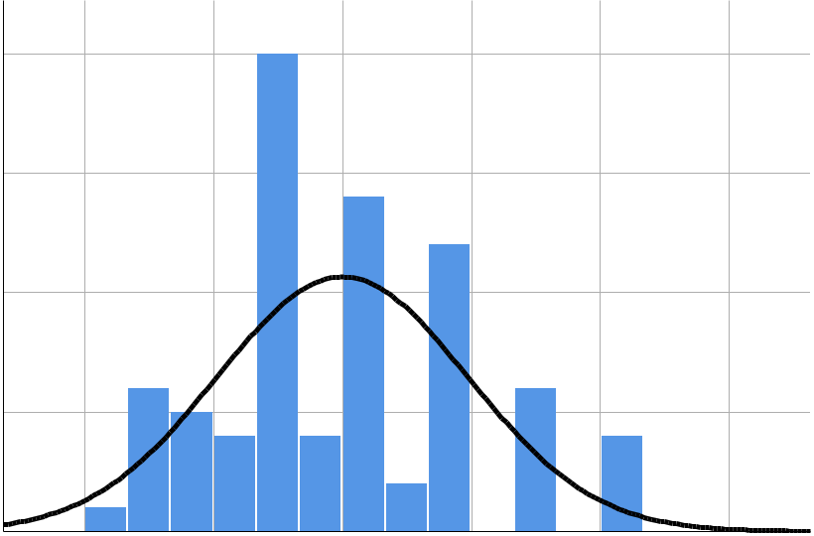

 |  |  |  |  |  | Mean = - 3 . 1 7 E - 1 6
 | 2 0 |  |  |  |  | Std. Dev. = 0 . 9 7 4
 |  |  |  |  |  | N =78
 | 1 5
Frequency | 1 0
 | 5
 | 0
 | - 2 | - 1 | 0 | 1 | 2 | 3

Regression Standardized Residual

Normal P-P Plot of Regression Standardized Residual

Dependent Variable: Semanticlanguagescores
1 . 0
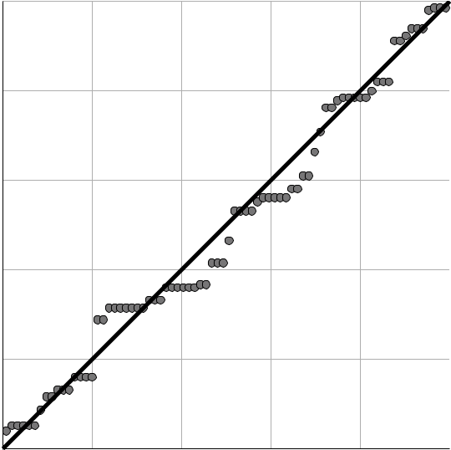

0 . 8

Expected Cum Prob

0 . 6

0 . 4

0 . 2

0 . 0
0.0 0.2 0.4 0.6 0.8 1.0

Observed Cum Prob

Page 3

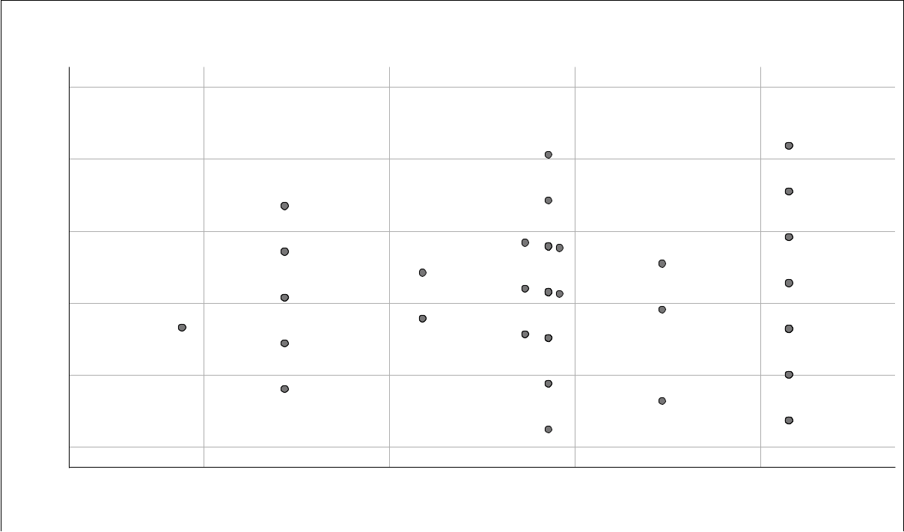
Scatterplot

Dependent Variable: Semanticlanguagescores

Regression Standardized Residual

3

2

1

0

- 1

- 2

-2 -1 0 1

Regression Standardized Predicted Value

REGRESSION

/MISSING LISTWISE

/STATISTICS COEFF OUTS R ANOVA CHANGE

/CRITERIA=PIN(.05) POUT(.10)

/NOORIGIN

/DEPENDENT Semanticlanguagescores

/METHOD=ENTER Deprivedenviroments_v2Chaoticenviroment_v2Poolivingcondit ions_v2

LowSESconditions_v2

/SCATTERPLOT=(*ZRESID ,*ZPRED)

/RESIDUALS DURBIN HISTOGRAM(ZRESID) NORMPROB(ZRESID)

/SAVE ZPRED COOK LEVER ZRESID.

Regression

Variables Entered/Removed ª

 | Variables | Variables
Model | Entered | Removed | Method
1 | LowSEScondit | . | Enter
 | ions_v2,
 | Deprivedenvi
 | roments_v2,
 | Chaoticenviro
 | ment_v2,
 | Poorlivingcon
 | ditions_v2^{b}

- Dependent Variable: Semanticlanguagescores

- All requested variables entered.

Page 4

Model Summary ^{b}

 |  |  |  |  |  |  |  | Change Statistics
 |  |  |  |  | Adjusted R |  | Std. Error of | R Square
Model | R |  | R Square |  | Square |  | the Estimate | Change | F Change
1 | . 376 ª |  | .141 |  | .094 |  | 1.572 | .141 | 2.999
 |  |  |  |  | Model Summary ^{b}
 |  | Change Statistics
 |  |  |  |  |  |  | Durbin-
Model | df1 |  | df2 |  | Sig. F Change |  | Watson
1 | 4 |  | 7 3 |  | .024 |  | 1.971

- Predictors: (Constant), LowSESconditions_v2, Deprivedenviroments_v2, Chaoticenviroment_v2, Poorlivingconditions_v2

- Dependent Variable: Semanticlanguagescores

ANOVAª

 |  | Sum of
Model |  | Squares |  | df | Mean Square | F | Sig.
1 | Regression | 29 | .664 | 4 | 7.416 | 2.999 | . 024 ^{b}
 | Residual | 180 | .489 | 7 3 | 2.472
 | Total | 210 | .154 | 7 7

- Dependent Variable: Semanticlanguagescores

- Predictors: (Constant), LowSESconditions_v2, Deprivedenviroments_v2, Chaoticenviroment_v2, Poorlivingconditions_v2

Coefficientsª

 |  |  |  |  | Standardized
 |  | Unstandardized Coefficients |  |  | Coefficients
Model |  | B |  | Std. Error | Beta | t
1 | (Constant) | 6.794 |  | .809 |  | 8.400
 | Deprivedenviroments_v2 | 1.224 |  | .631 | .360 | 1.940
 | Chaoticenviroment_v2 | .343 |  | .666 | .093 | .515
 | Poorlivingconditions_v2 | -.458 |  | .805 | -.139 | - . 5 | 6 8
 | LowSESconditions_v2 | -1.261 |  | .798 | -.384 | -1.5 | 8 1

Page 5

Coefficientsª

Model |  | Sig.
1 | (Constant) | .000
 | Deprivedenviroments_v2 | .056

Chaoticenviroment_v2 . 6 0 8

Poorlivingconditions_v2 . 5 7 1

LowSESconditions_v2 . 1 1 8

a. Dependent Variable: Semanticlanguagescores

Residuals Statisticsª

 | Minimum | Maximum |  | Mean | Std. Deviation | N
Predicted Value | 5.53 |  | 7.56 | 6.85 | .621 | 7 8
Std. Predicted Value | -2.116 | 1 | .151 | .000 | 1.000 | 7 8
Standard Error of | .285 |  | .809 | .373 | .140 | 7 8
Predicted Value
Adjusted Predicted Value | 5.64 |  | 7.77 | 6.85 | .629 | 7 8
Residual | -2.757 | 3 | .439 | .000 | 1.531 | 7 8
Std. Residual | -1.754 | 2 | .187 | .000 | .974 | 7 8
Stud. Residual | -1.786 | 2 | .224 | .000 | .998 | 7 8
Deleted Residual | -2.862 | 3 | .556 | -.001 | 1.611 | 7 8
Stud. Deleted Residual | -1.814 | 2 | .288 | .002 | 1.009 | 7 8
Mahal. Distance | 1.546 | 19 | .385 | 3.949 | 4.419 | 7 8
Cook's Distance | .000 |  | .142 | .011 | .019 | 7 8
Centered Leverage Value | .020 |  | .252 | .051 | .057 | 7 8

a. Dependent Variable: Semanticlanguagescores

Charts

Page 6

Histogram

Dependent Variable: Semanticlanguagescores

 |  |  |  |  |  | Mean = - 3 . 1 7 E - 1 6
 | 2 0 |  |  |  |  | Std. Dev. = 0 . 9 7 4
 |  |  |  |  |  | N =78
 | 1 5
Frequency | 1 0
 | 5
 | 0
 | - 2 | - 1 | 0 | 1 | 2 | 3

Regression Standardized Residual

Normal P-P Plot of Regression Standardized Residual

Dependent Variable: Semanticlanguagescores
1 . 0

0 . 8

Expected Cum Prob

0 . 6

0 . 4

0 . 2

0 . 0
0.0 0.2 0.4 0.6 0.8 1.0

Observed Cum Prob

Page 7

Scatterplot

Dependent Variable: Semanticlanguagescores
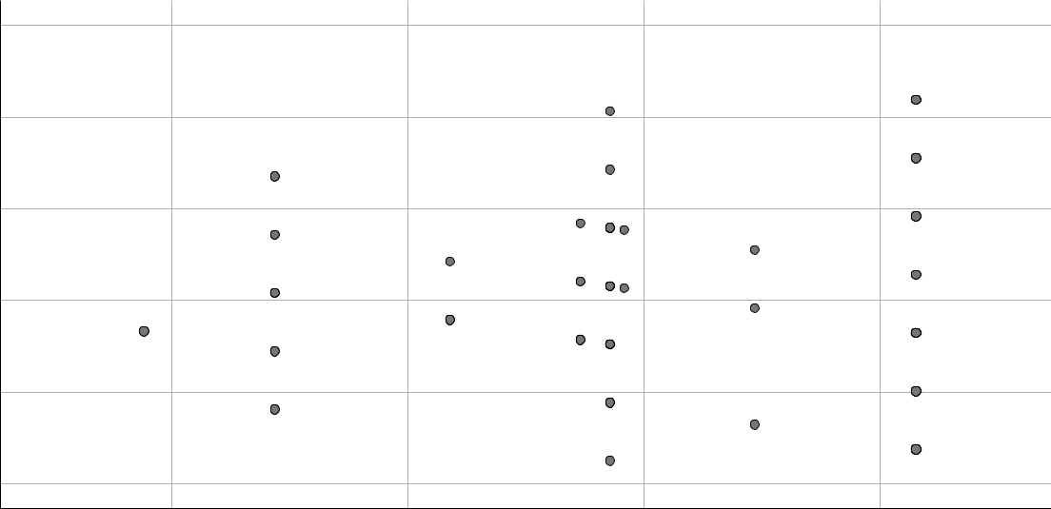

Regression Standardized Residual

3

2

1

0

- 1

- 2

-2 -1 0 1

Regression Standardized Predicted Value

GRAPH

/SCATTERPLOT(BIVAR)=ZPR_13 WITH ZRE_13

/MISSING=LISTWISE.

Graph
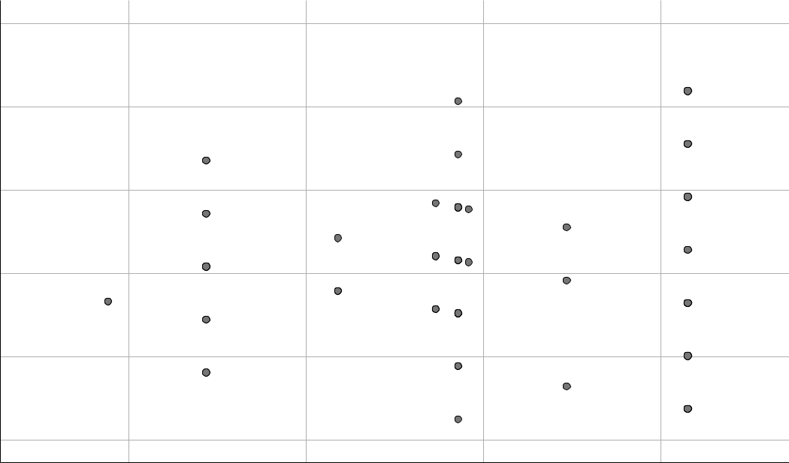

Standardized Residual

3.00000

2.00000

1.00000

.00000

-1.00000

-2.00000

-2.00000 -1.00000 .00000 1.00000

Standardized Predicted Value

REGRESSION

Page 8

/DESCRIPTIVES MEAN STDDEV CORR SIG N

/MISSING LISTWISE

/STATISTICS COEFF OUTS CI(95) BCOV R ANOVA COLLIN TOL /CRITERIA=PIN(.05) POUT(.10) /NOORIGIN

/DEPENDENT Semanticlanguagescores

/METHOD=ENTER Deprivedenviroments_v2Chaoticenviroment_v2Poolivingcondit ions_v2

LowSESconditions_v2

/SCATTERPLOT=(*ZRESID ,*ZPRED).

Regression

Descriptive Statistics

 | Mean | Std. Deviation | N
Semanticlanguagescores | 6.85 | 1.652 | 7 8
Deprivedenviroments_v2 | . 63 | .486 | 7 8
Chaoticenviroment_v2 | . 27 | .446 | 7 8
Poorlivingconditions_v2 | . 46 | .502 | 7 8
LowSESconditions_v2 | . 47 | .503 | 7 8

Correlations

 |  | Semanticlangu | Deprivedenvir | Chaoticenviro
 |  | agescores | oments_v2 | ment_v2
Pearson Correlation | Semanticlanguagescores | 1.000 | .267 | -.207
 | Deprivedenviroments_v2 | .267 | 1.000 | -.789
 | Chaoticenviroment_v2 | -.207 | -.789 | 1.000
 | Poorlivingconditions_v2 | .243 | .180 | -.214
 | LowSESconditions_v2 | -.255 | -.013 | .118
Sig. (1-tailed) | Semanticlanguagescores | . | .009 | .034
 | Deprivedenviroments_v2 | .009 | . | .000
 | Chaoticenviroment_v2 | .034 | .000 | .
 | Poorlivingconditions_v2 | .016 | .057 | .030
 | LowSESconditions_v2 | .012 | .455 | .152
N | Semanticlanguagescores | 7 8 | 7 8 | 7 8
 | Deprivedenviroments_v2 | 7 8 | 7 8 | 7 8
 | Chaoticenviroment_v2 | 7 8 | 7 8 | 7 8
 | Poorlivingconditions_v2 | 7 8 | 7 8 | 7 8
 | LowSESconditions_v2 | 7 8 | 7 8 | 7 8

Page 9

 | Correlations
 |  | Poorlivingcondi | LowSESconditio
 |  | tions_v2 | ns_v2
Pearson Correlation | Semanticlanguagescores | .243 | -.255
 | Deprivedenviroments_v2 | .180 | -.013
 | Chaoticenviroment_v2 | -.214 | .118
 | Poorlivingconditions_v2 | 1.000 | -.879
 | LowSESconditions_v2 | -.879 | 1.000
Sig. (1-tailed) | Semanticlanguagescores | .016 | .012
 | Deprivedenviroments_v2 | .057 | .455
 | Chaoticenviroment_v2 | .030 | .152
 | Poorlivingconditions_v2 | . | .000
 | LowSESconditions_v2 | .000 | .
N | Semanticlanguagescores | 7 8 | 7 8
 | Deprivedenviroments_v2 | 7 8 | 7 8
 | Chaoticenviroment_v2 | 7 8 | 7 8
 | Poorlivingconditions_v2 | 7 8 | 7 8
 | LowSESconditions_v2 | 7 8 | 7 8

Variables Entered/Removed ª

 | Variables | Variables
Model | Entered | Removed | Method
1 | LowSEScondit | . | Enter
 | ions_v2,
 | Deprivedenvi
 | roments_v2,
 | Chaoticenviro
 | ment_v2,
 | Poorlivingcon
 | ditions_v2^{b}

- Dependent Variable: Semanticlanguagescores

- All requested variables entered.

Model Summary ^{b}

 |  |  | Adjusted R | Std. Error of
Model | R | R Square | Square | the Estimate
1 | . 376 ª | .141 | .094 | 1.572

- Predictors: (Constant), LowSESconditions_v2, Deprivedenviroments_v2, Chaoticenviroment_v2, Poorlivingconditions_v2

- Dependent Variable: Semanticlanguagescores

Page 10

ANOVAª

 |  | Sum of
Model |  | Squares |  | df | Mean Square | F | Sig.
1 | Regression | 29 | .664 | 4 | 7.416 | 2.999 | . 024 ^{b}
 | Residual | 180 | .489 | 7 3 | 2.472
 | Total | 210 | .154 | 7 7

- Dependent Variable: Semanticlanguagescores

- Predictors: (Constant), LowSESconditions_v2, Deprivedenviroments_v2, Chaoticenviroment_v2, Poorlivingconditions_v2

Coefficientsª

 |  |  |  |  | Standardized
 |  | Unstandardized Coefficients |  |  | Coefficients
Model |  | B |  | Std. Error | Beta | t
1 | (Constant) | 6.794 |  | .809 |  | 8.400
 | Deprivedenviroments_v2 | 1.224 |  | .631 | .360 | 1.940
 | Chaoticenviroment_v2 | .343 |  | .666 | .093 | .515
 | Poorlivingconditions_v2 | -.458 |  | .805 | -.139 | - . 5 | 6 8
 | LowSESconditions_v2 | -1.261 |  | .798 | -.384 | -1.5 | 8 1

Coefficientsª

 |  |  |  |  |  |  | Collinearity
 |  |  |  | 95.0% Confidence Interval for B |  |  | Statistics
Model |  |  | Sig. | Lower Bound |  | Upper Bound | Tolerance
1 | (Constant) |  | .000 | 5.182 |  | 8.406
 | Deprivedenviroments_v2 |  | .056 | -.034 |  | 2.482 | .341
 | Chaoticenviroment_v2 |  | .608 | -.984 |  | 1.670 | .363
 | Poorlivingconditions_v2 |  | .571 | -2.063 |  | 1.147 | .197
 | LowSESconditions_v2 |  | .118 | -2.851 |  | .329 | .200
 |  |  | Coefficientsª
 |  | Collinearity
 |  |  | Statistics
Model |  |  | VIF

- (Constant)

Deprivedenviroments_v22 .936

Chaoticenviroment_v22 .753

Poorlivingconditions_v25 .086

LowSESconditions_v25 .006

  - Dependent Variable: Semanticlanguagescores

Page 11

Coefficient Correlations ª

 |  |  | LowSESconditio |  | Deprivedenvir | Chaoticenviro
Model |  |  | ns_v2 |  | oments_v2 | ment_v2
1 | Correlations | LowSESconditions_v2 | 1.000 |  | -.312 | -.154
 |  | Deprivedenviroments_v2 | -.312 |  | 1.000 | .781
 |  | Chaoticenviroment_v2 | -.154 |  | .781 | 1.000
 |  | Poorlivingconditions_v2 | .891 |  | -.286 | -.084
 | Covariances | LowSESconditions_v2 | .636 |  | -.157 | -.082
 |  | Deprivedenviroments_v2 | -.157 |  | .398 | .328
 |  | Chaoticenviroment_v2 | -.082 |  | .328 | .443
 |  | Poorlivingconditions_v2 | .573 |  | -.145 | -.045
 |  | Coefficient Correlations ª
 |  |  | Poorlivingcondi
Model |  |  | tions_v2
1 | Correlations | LowSESconditions_v2 | .891
 |  | Deprivedenviroments_v2 | -.286
 |  | Chaoticenviroment_v2 | -.084
 |  | Poorlivingconditions_v2 | 1.000
 | Covariances | LowSESconditions_v2 | .573
 |  | Deprivedenviroments_v2 | -.145

Chaoticenviroment_v2 - . 0 4 5

Poorlivingconditions_v2 . 6 4 9

a. Dependent Variable: Semanticlanguagescores

Collinearity Diagnostics ª

 |  |  |  |  | Variance Proportions
 |  |  | Condition |  | Deprivedenvir |  | Chaoticenviro
Model | Dimension | Eigenvalue | Index | (Constant) | oments_v2 |  | ment_v2
1 | 1 | 2.902 | 1.000 | . 01 | . 01 |  | . 01
 | 2 | 1.159 | 1.583 | . 00 | . 01 |  | . 09
 | 3 | .844 | 1.854 | . 00 | . 02 |  | . 11
 | 4 | .066 | 6.656 | . 07 | . 93 |  | . 71
 | 5 | .030 | 9.877 | . 92 | . 02 |  | . 09

Page 12

Collinearity Diagnostics ª

 |  | Variance Proportions
 |  | Poorlivingcondi | LowSESconditio
Model | Dimension | tions_v2 | ns_v2
1 | 1 | . 01 | . 01
 | 2 | . 02 | . 02
 | 3 | . 03 | . 03
 | 4 | . 18 | . 22
 | 5 | . 76 | . 72

a. Dependent Variable: Semanticlanguagescores

Residuals Statisticsª

 | Minimum | Maximum | Mean | Std. Deviation | N
Predicted Value | 5.53 | 7.56 | 6.85 | .621 | 7 8
Residual | -2.757 | 3.439 | .000 | 1.531 | 7 8
Std. Predicted Value | -2.116 | 1.151 | .000 | 1.000 | 7 8
Std. Residual | -1.754 | 2.187 | .000 | .974 | 7 8

a. Dependent Variable: Semanticlanguagescores

Charts

Regression Standardized Residual

Scatterplot

Dependent Variable: Semanticlanguagescores

3

2

1

0

- 1

- 2

-2 -1 0 1

Regression Standardized Predicted Value

Page 13

